Name: Class:

Task 1
- This image uses four colours so requires 2 bits per pixel. Fill each pixel in the image as a computer using the key.
10 | 10 | 10 | 10 | 10 | 10 | 10 | 10 | 10 | 10 | 10 | 10 | 10 | 10
10 | 00 | 00 | 10 | 00 | 00 | 10 | 00 | 00 | 10 | 00 | 00 | 00 | 10
10 | 00 | 00 | 10 | 00 | 00 | 10 | 00 | 00 | 10 | 00 | 00 | 00 | 10
10 | 10 | 10 | 10 | 10 | 10 | 10 | 10 | 10 | 10 | 10 | 10 | 10 | 10
10 | 00 | 00 | 10 | 00 | 00 | 10 | 00 | 00 | 10 | 00 | 00 | 00 | 10
10 | 00 | 00 | 10 | 00 | 00 | 10 | 00 | 00 | 10 | 00 | 00 | 00 | 10
10 | 00 | 11 | 10 | 10 | 10 | 10 | 10 | 10 | 10 | 10 | 10 | 10 | 10
10 | 11 | 11 | 10 | 10 | 10 | 10 | 10 | 10 | 10 | 10 | 10 | 01 | 01
10 | 10 | 10 | 10 | 11 | 11 | 10 | 10 | 10 | 10 | 11 | 11 | 10 | 10
00 | 00 | 00 | 00 | 11 | 11 | 00 | 00 | 00 | 00 | 11 | 11 | 00 | 00

Key: | 01 | 00 | 11 | 10

- Calculate the file size of the following images:
 | Image Resolution | Number of colours | Colour depth in bits | File size in bits | File size in Bytes
Image 1 | 20 x 20 | 8
Image 2 | 10 x 10 | 8
Image 3 | 20 x 20 | 4
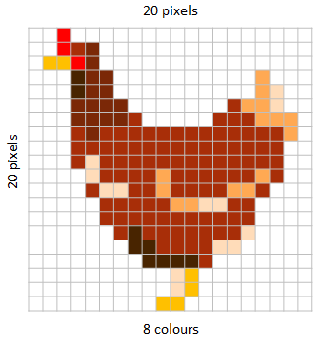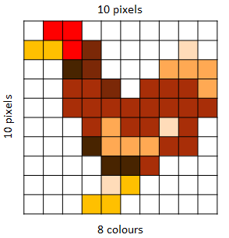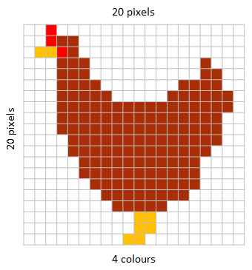

- How does increasing the image resolution affect the file size?

- Explain the relationship between image quality and file size

Task 2
- Using the following bit pattern, shade in the pixel grid to create a black and white bitmap to create an image where black = 1 and white = 0: 00100 01110 11111 00100 01100

- What is the bit pattern for the following icon image where black = 1 and white = 0?

